Galvez, Patrick Louis V. C335_IT

2023-1-01545 Oct 14, 2025

**PHP STEP-BY-STEP INSTALLATION**

Go to php.net/downloads.php

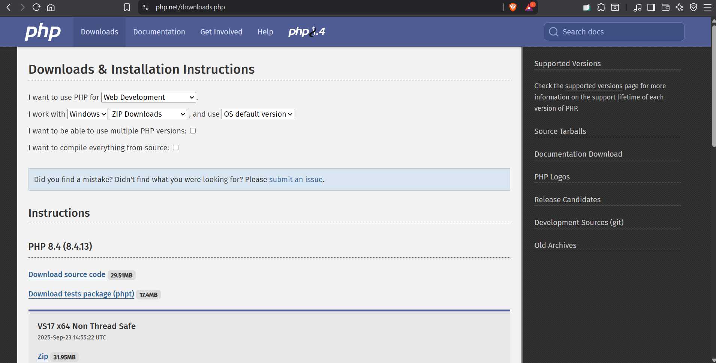

Download the zip file under “VS17 x64 Thread Safe”

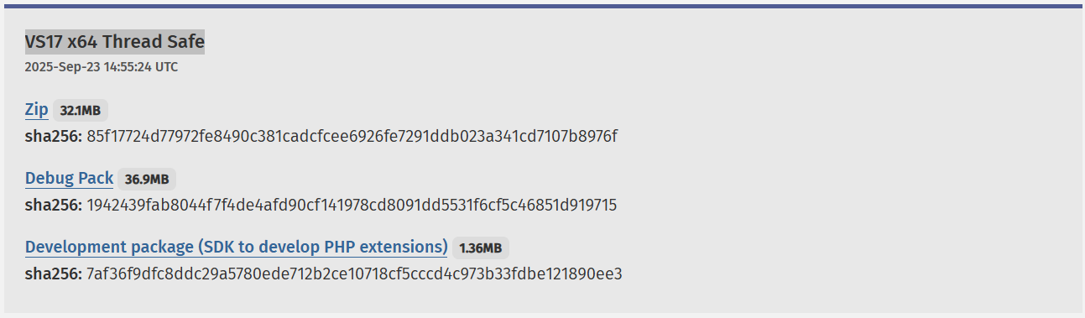

Extract the zip file

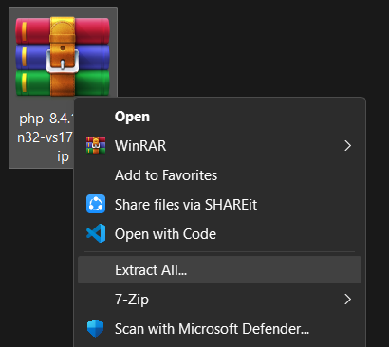

Rename the folder—leaving only php-versionnumber

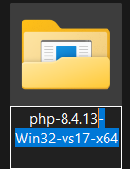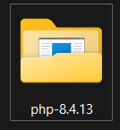

Move the folder to your main drive

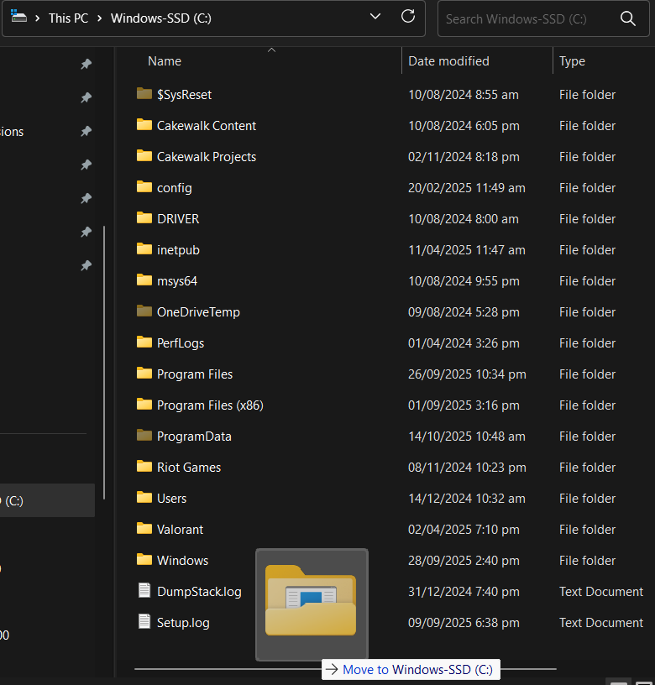

Enter the folder and copy the file path

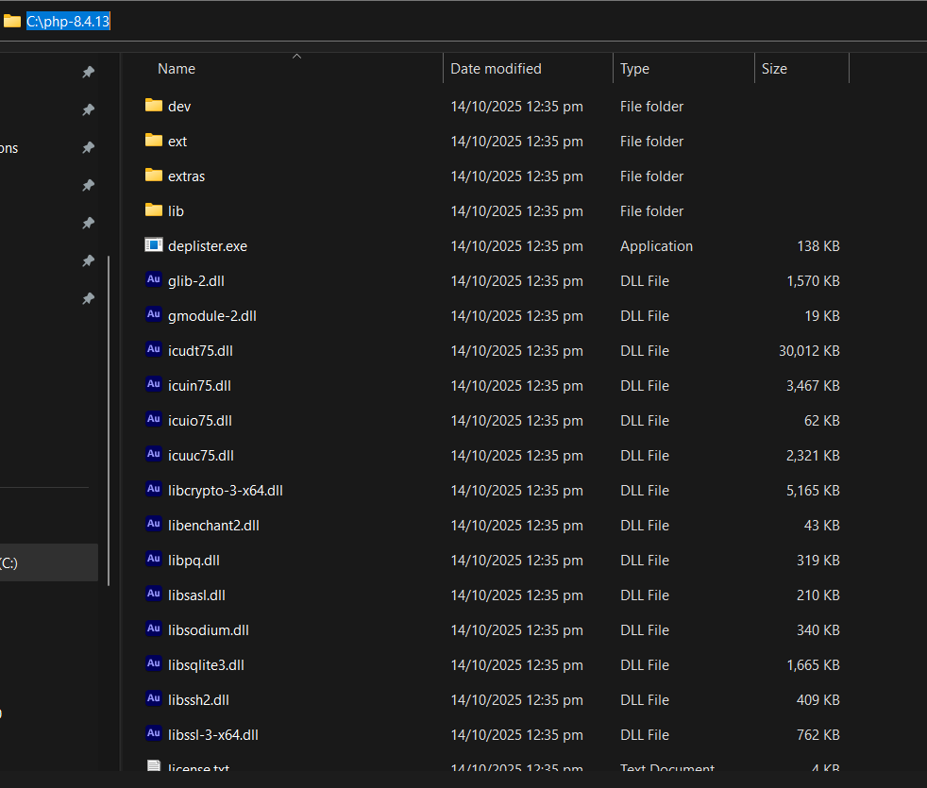

Type “Environment variables” in the start menu search and click on “Edit environment variables for your account”

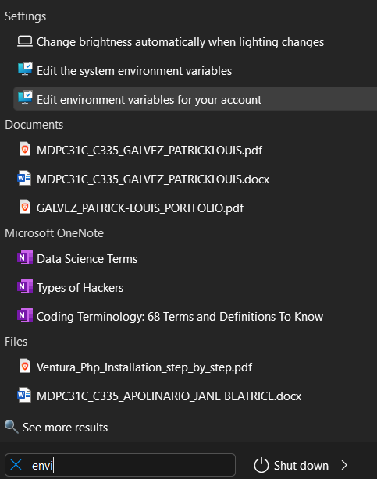

If you want to add the variable only to the current user then use the top section, if you want it for the entire system then use the bottom section. Following steps are the same regardless

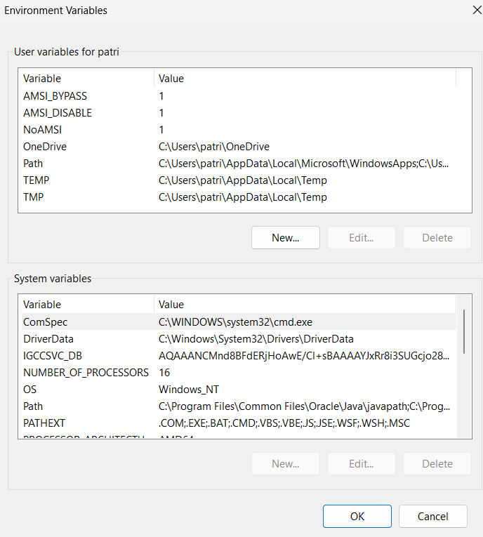

Select “Path” then Edit

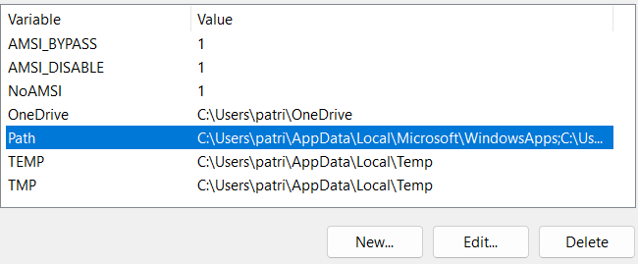

Click “New” and paste the previously copied file path

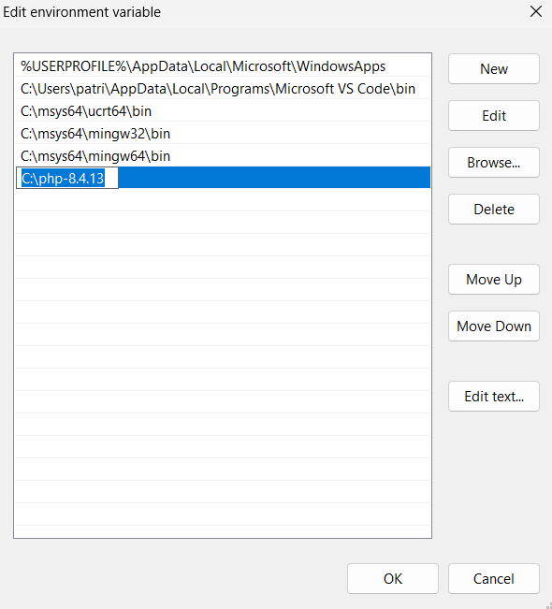

Press ok in both windows and open command prompt after closing it

Type “php –version” and it should respond as shown

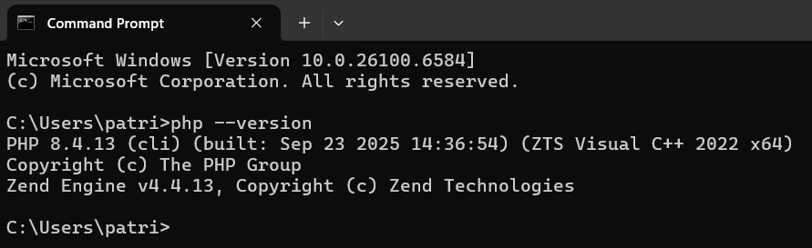

Done.

**MYSQL STEP-BY-STEP INSTALLATION**

Go to https://www.mysql.com/downloads/ , Scroll down, and select “MySQL Community (GPL) Downloads”

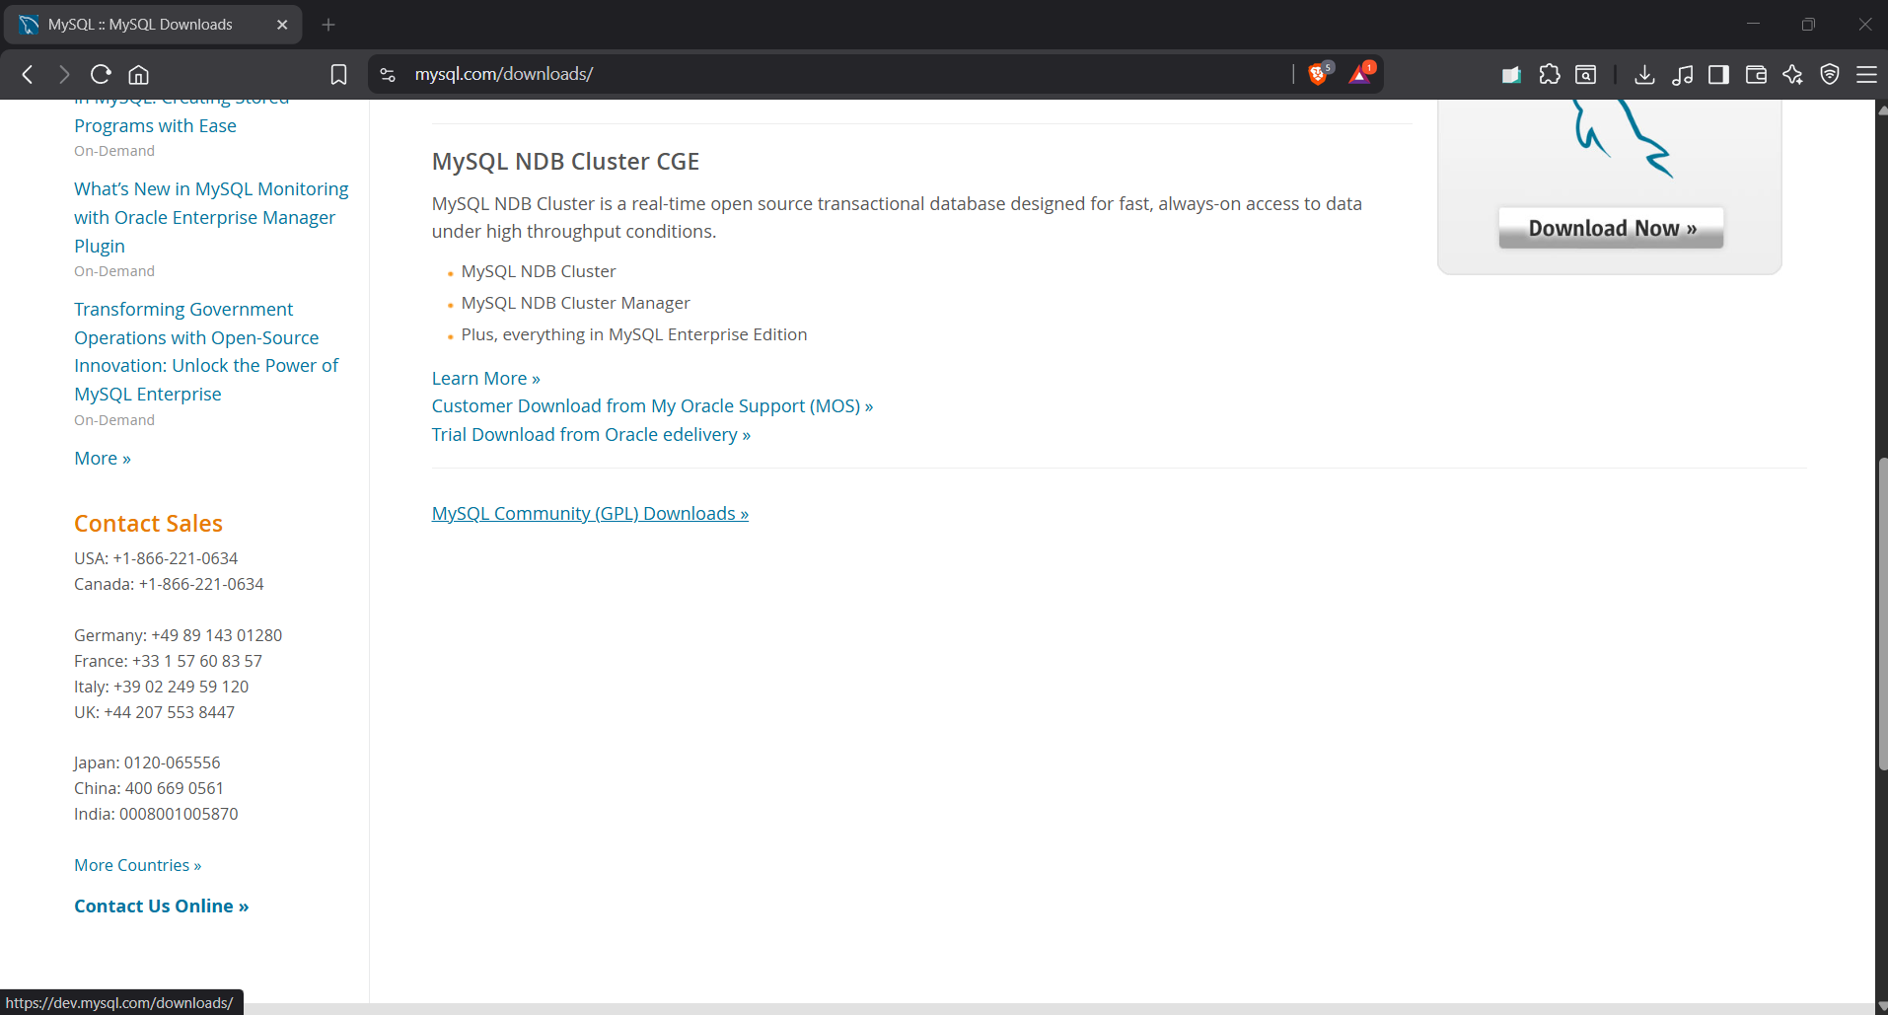

Click on MySQL Installer for Windows

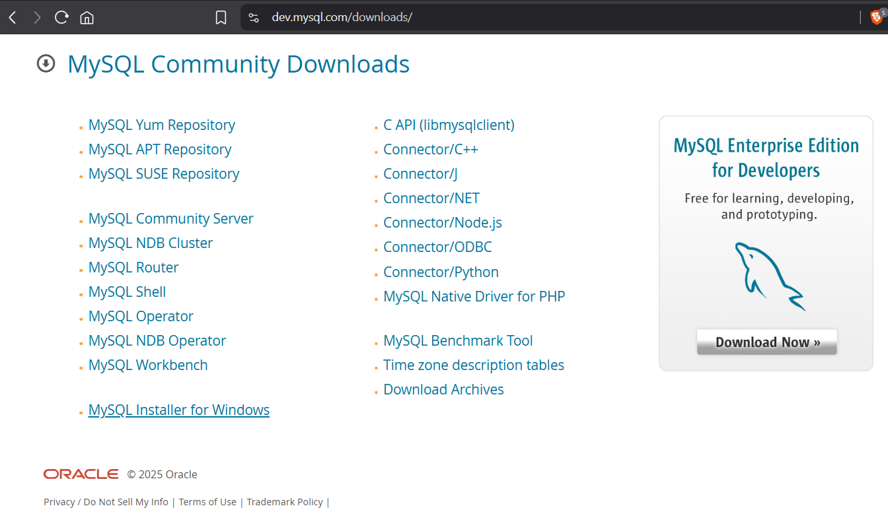

The page automatically defaults to the latest version and your operating system. Click on the second download file (With the larger file size)

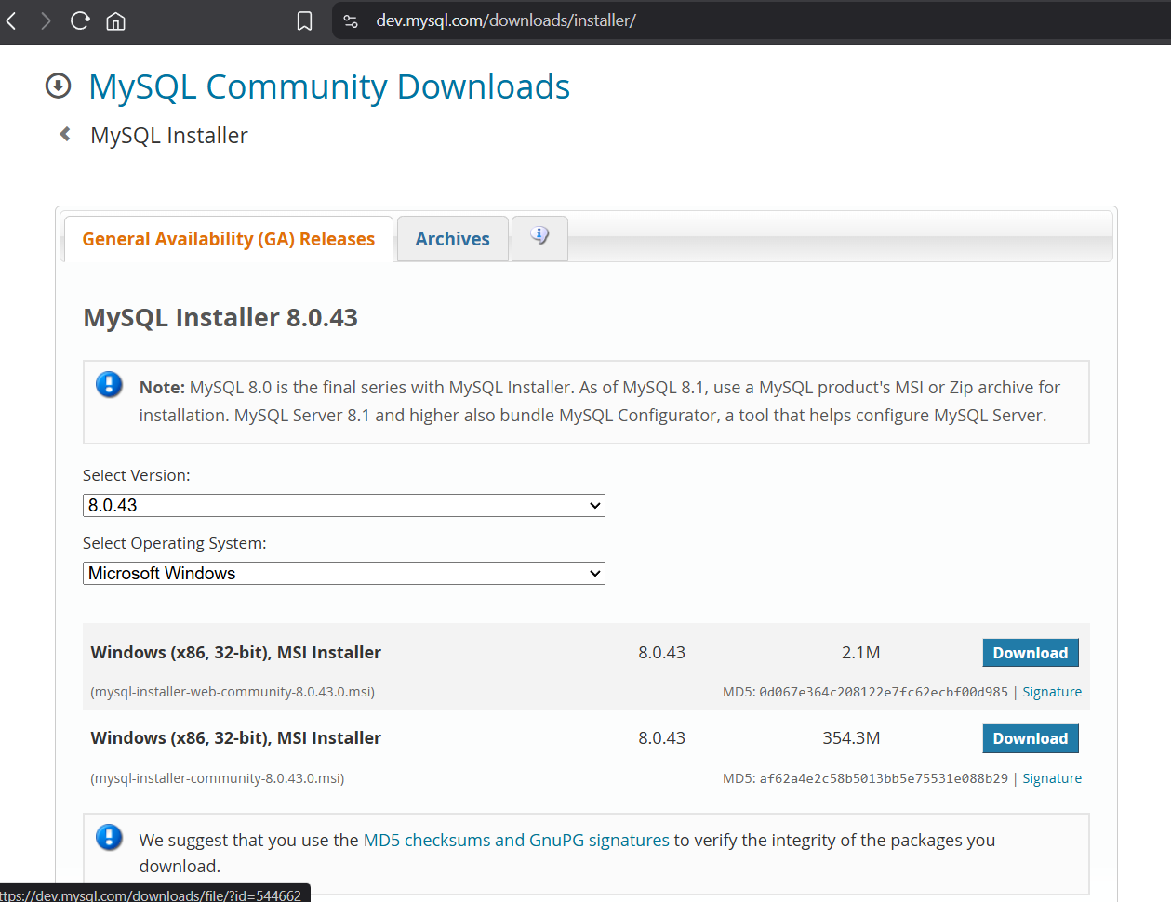

Click on “No thanks, just start my download.”

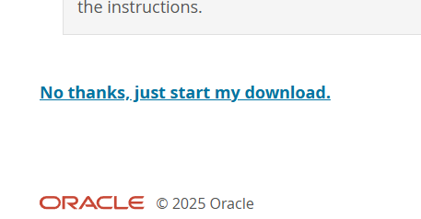

Open the downloaded file

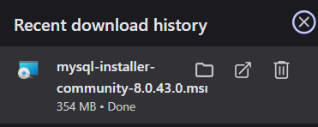

Select “Yes” on the system popups until the installer window appears

Click “Custom” then Next

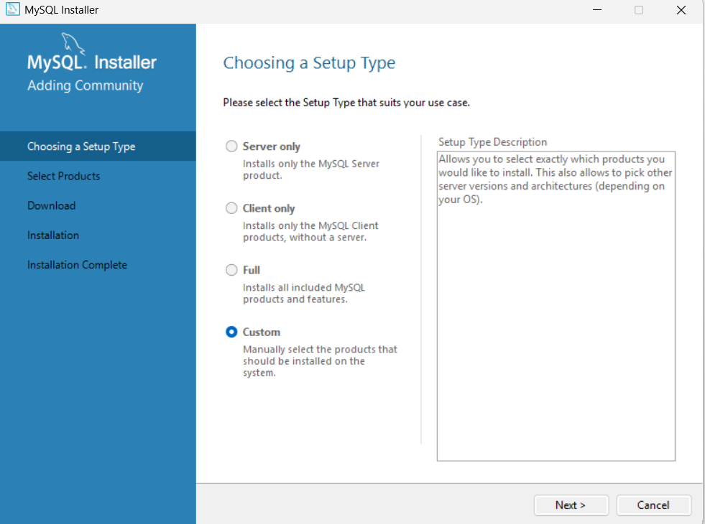

Open the “MySQL Servers” dropdown button as shown and then select the right arrow

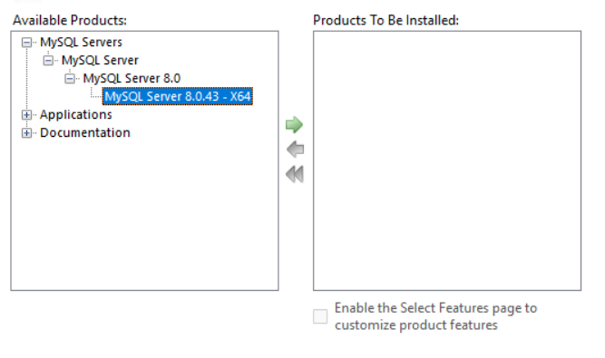

Open “Applications” as shown then select the right arrow again

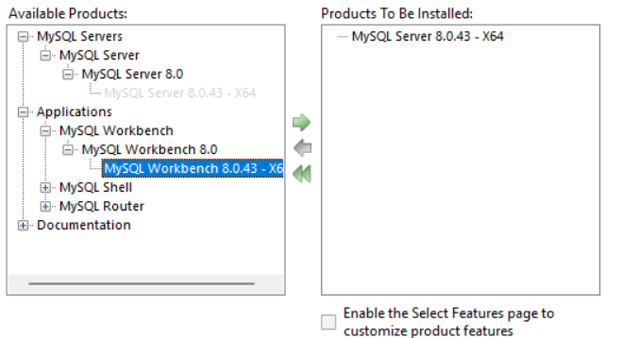

Do the same with MySQL Shell then click next

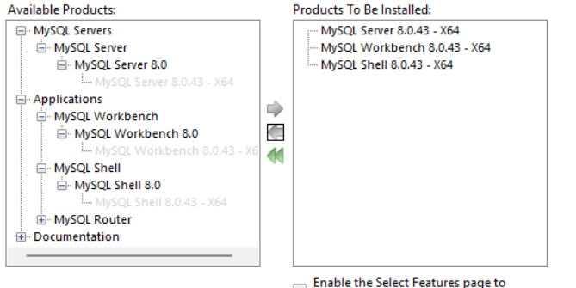

Click Execute

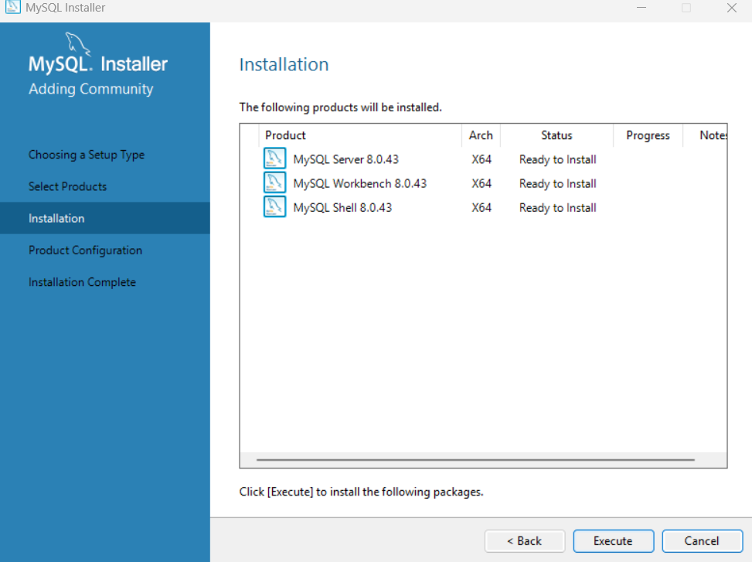

After everything finishes installing, click next

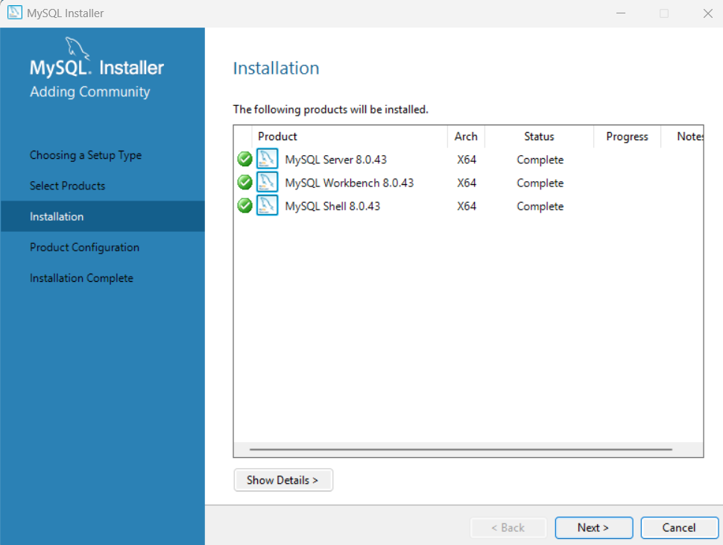

Click next again

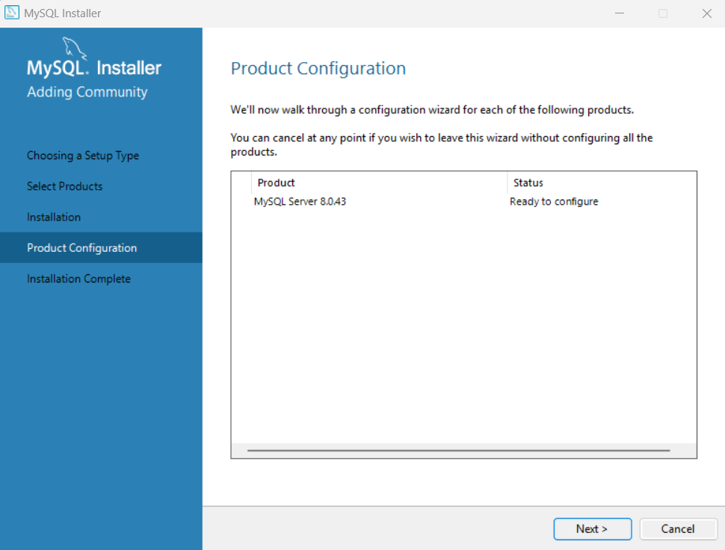

Next

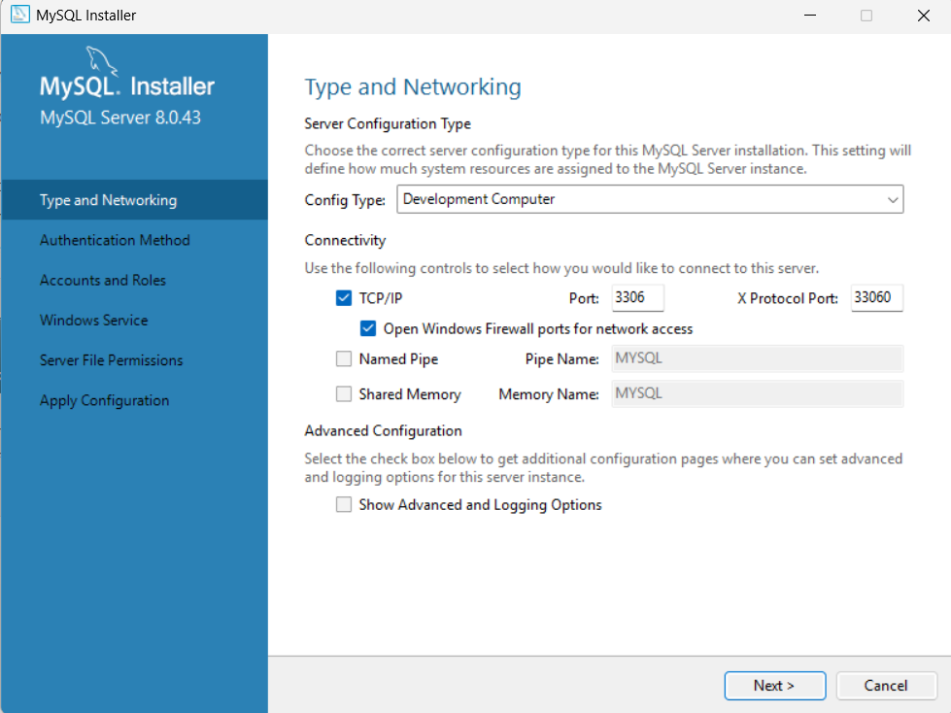

Next again

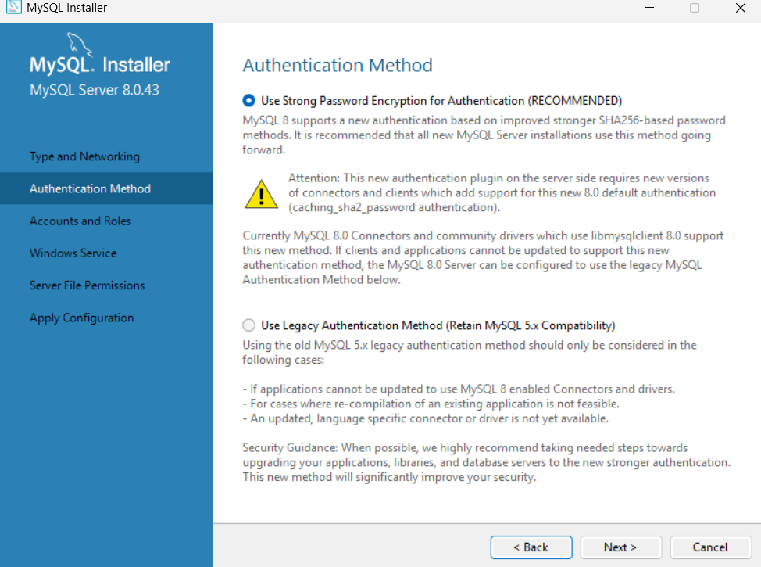

Set a root account password then click next

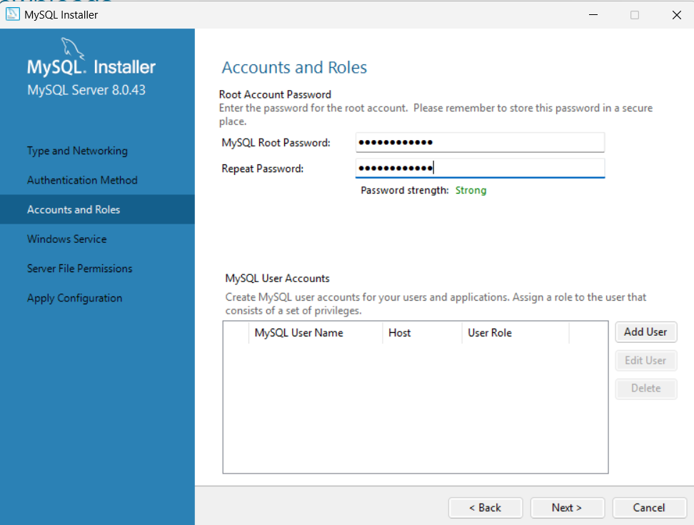

Next again

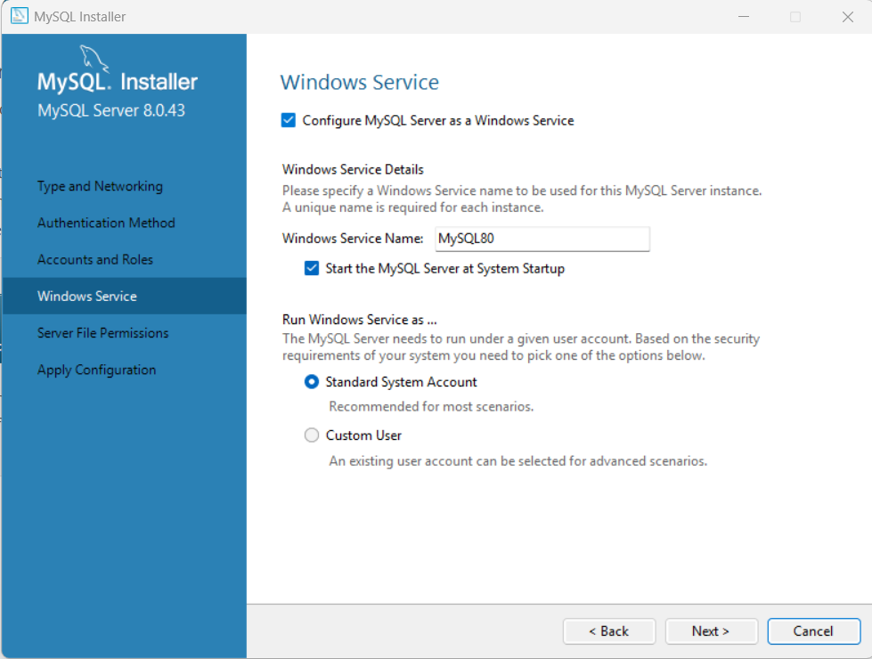

Next again

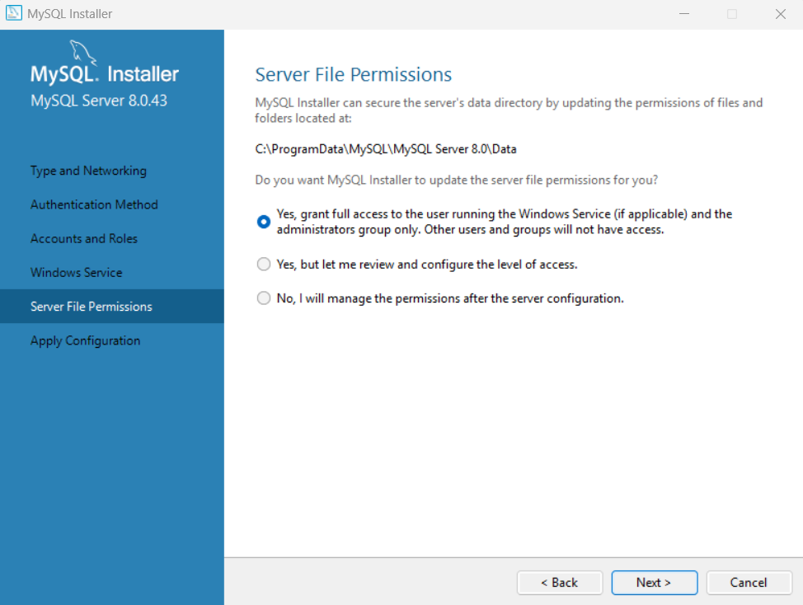

Click Execute

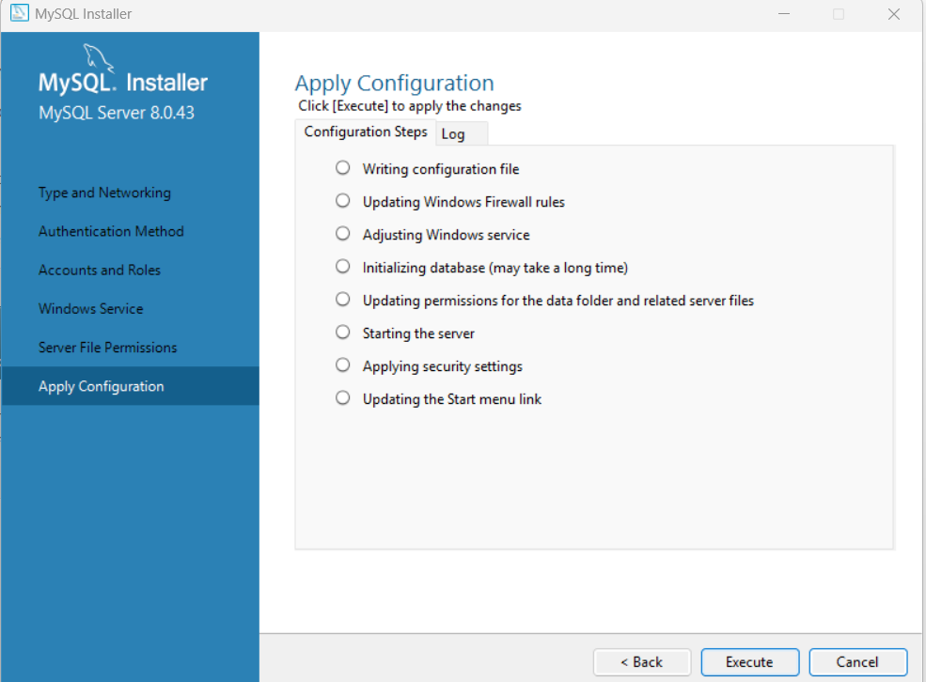

After the configuration is complete, click finish

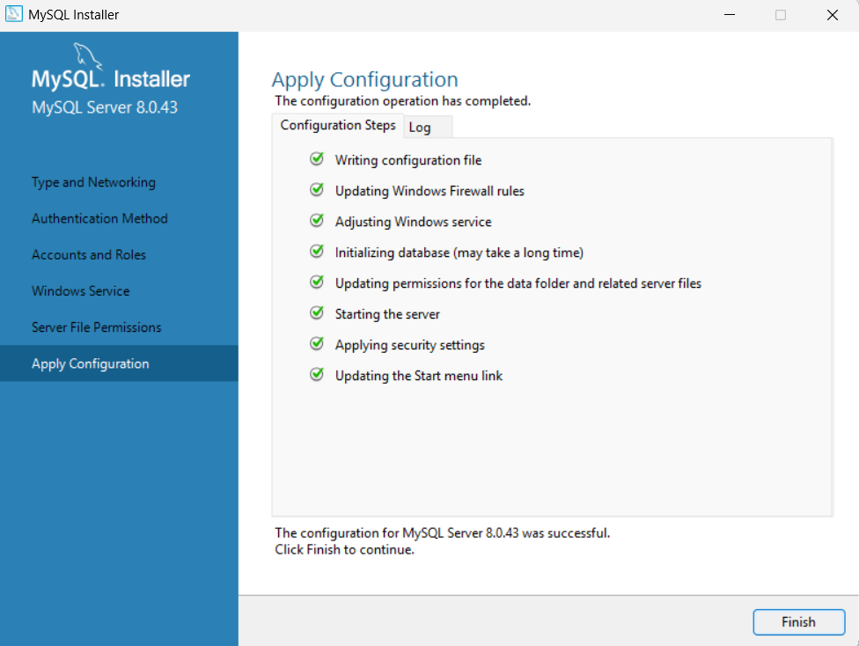

Click Next

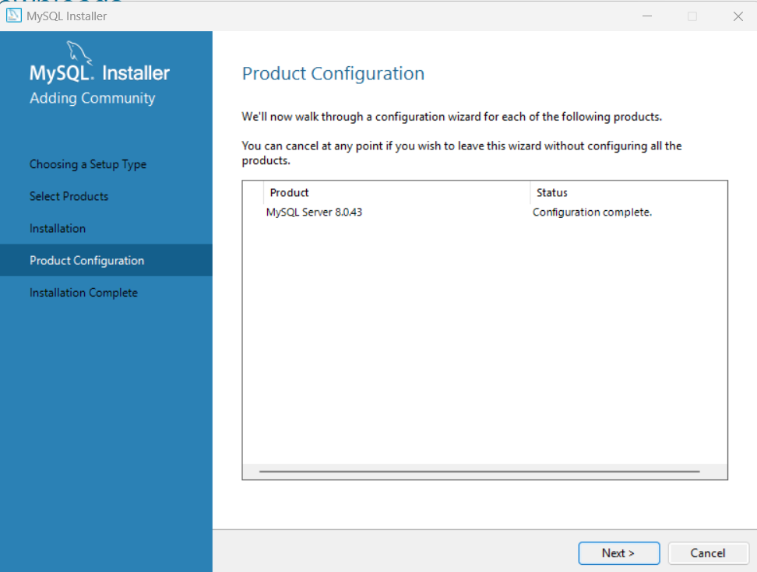

Click finish, making sure that the two check boxes are selected

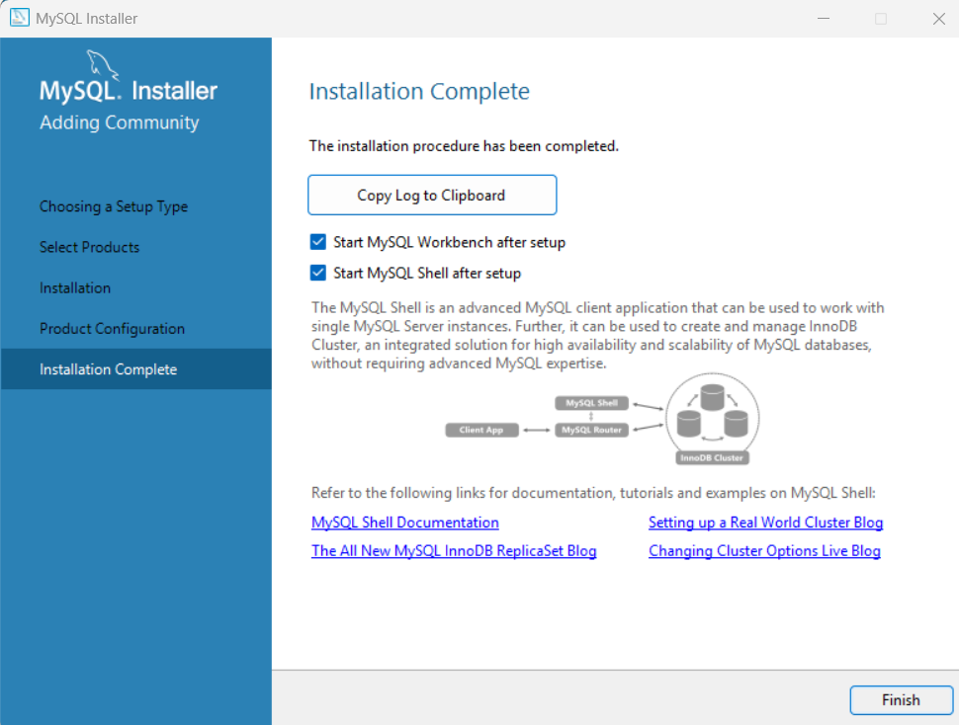

Two windows will open. For now, minimize them then go to your main drive

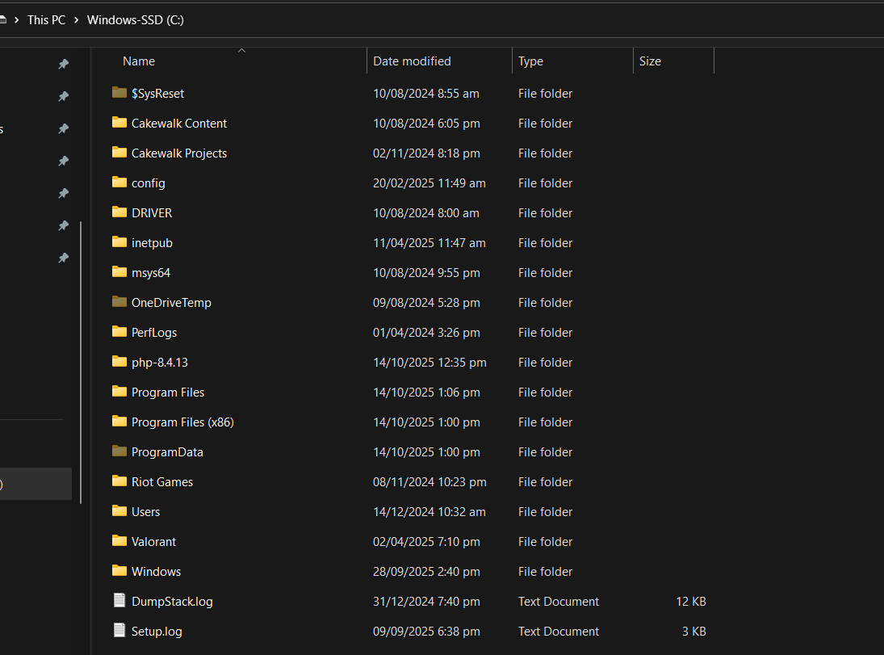

Follow this file path



Copy the file path



Type “Environment variables” in the start menu search and click on “Edit the system environment variables”

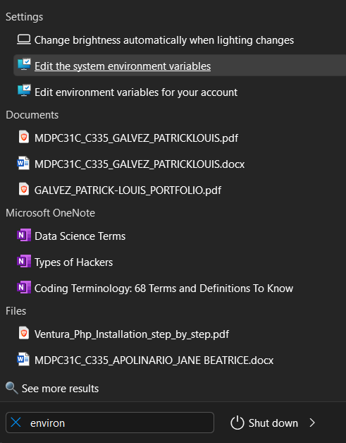

Click Environment Variables

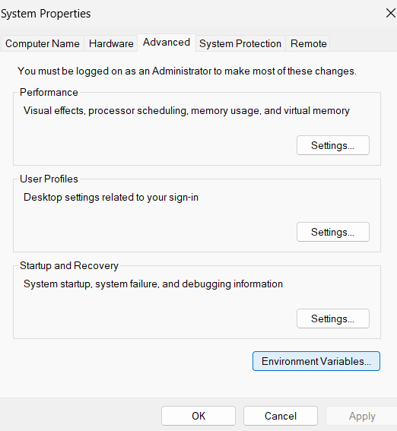

Double click on Path under System variables

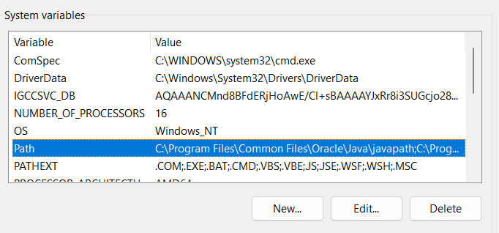

Click New then paste the file path in the new line. Then Click ok

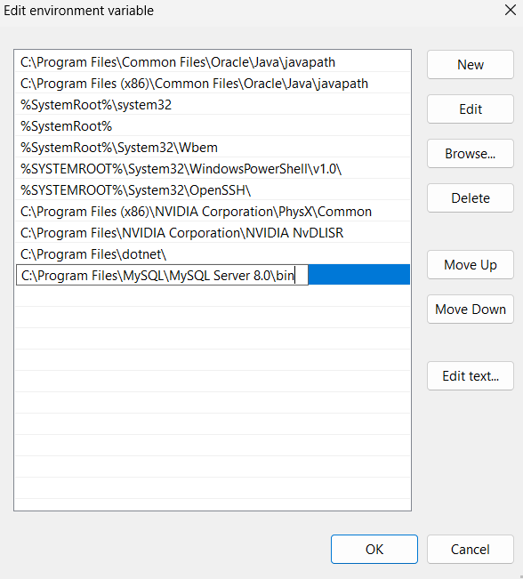

Ok

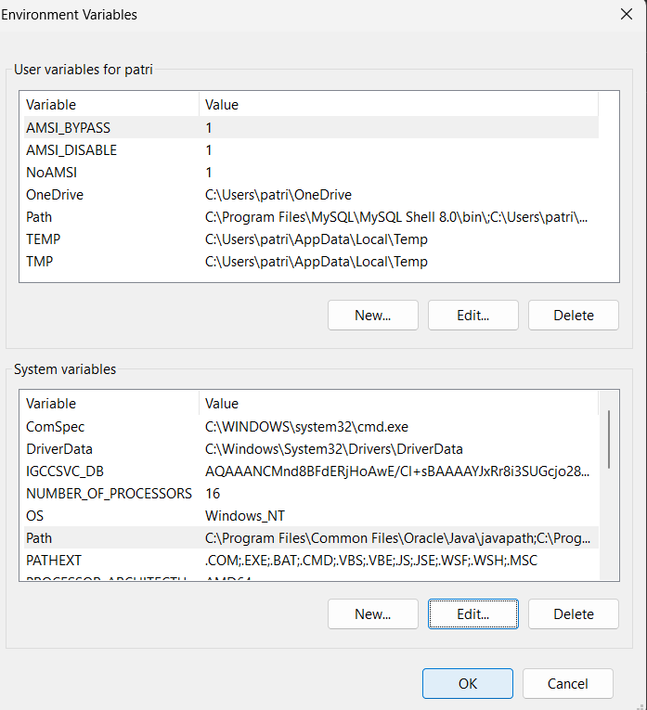

Ok

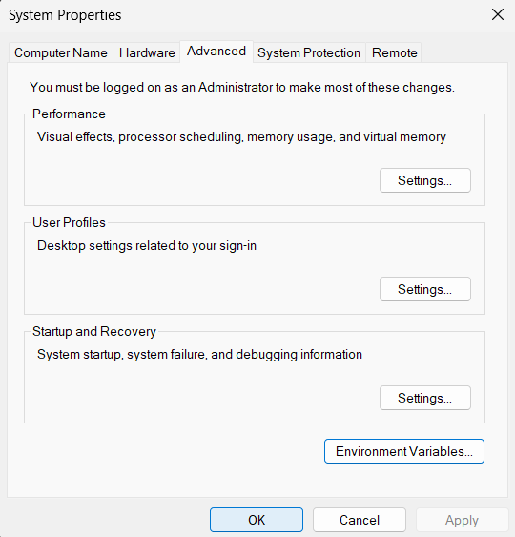

Go to start and open command prompt

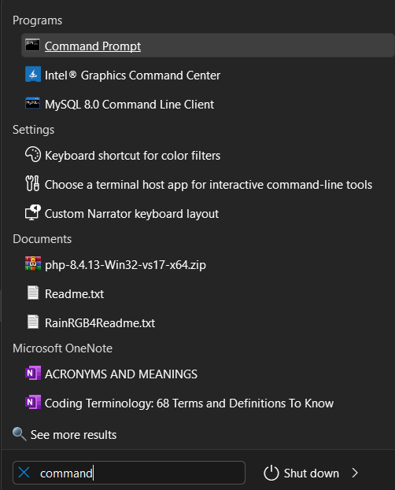

Type “mysql –version”

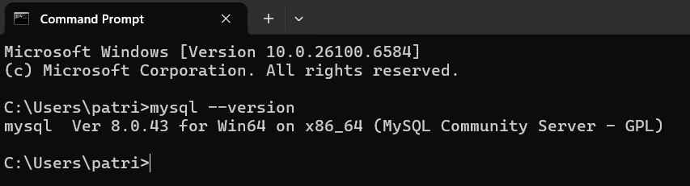

Type mysql -u -root -p then press enter

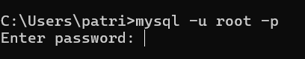

Type your password then enter



Done

**XAMPP STEP-BY-STEP INSTALLATION**

Go to https://www.apachefriends.org/ then click XAMPP for Windows  
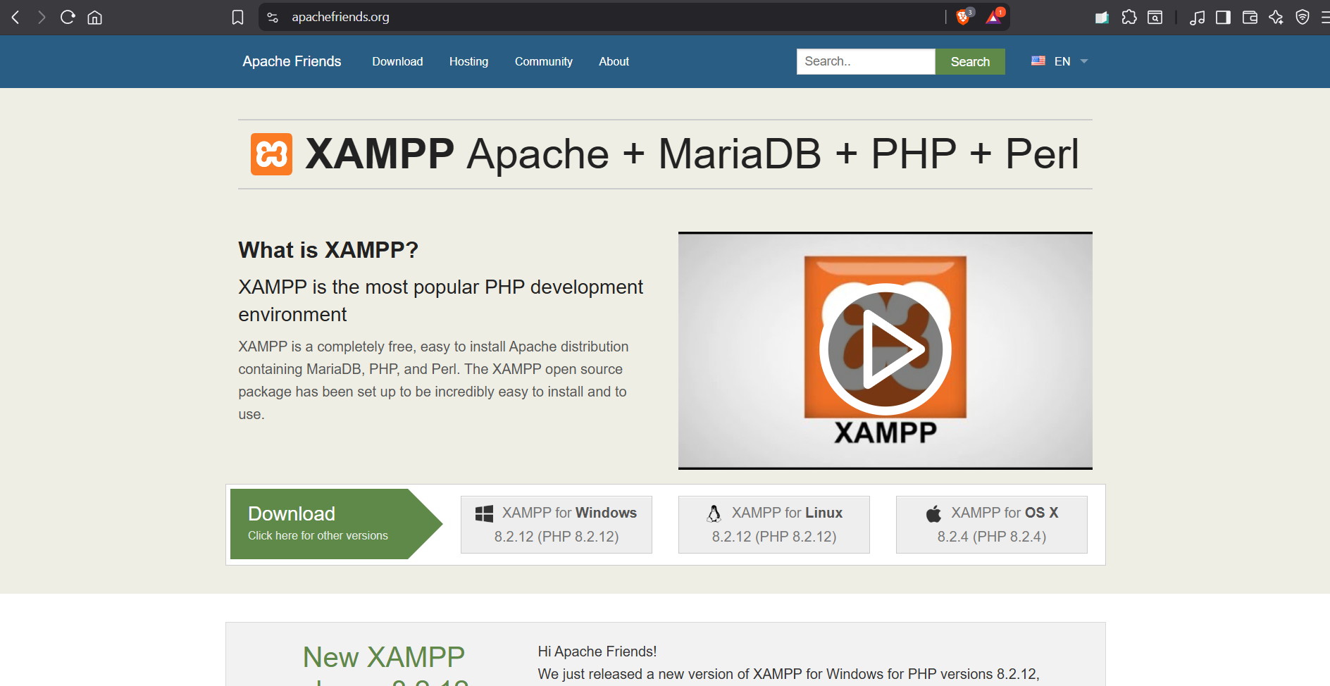

Open the file after downloading it

Click next

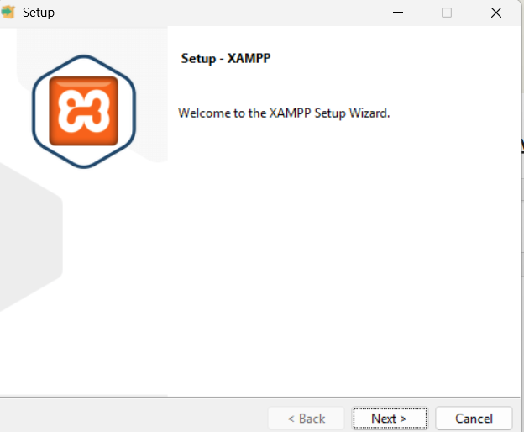

Click Next

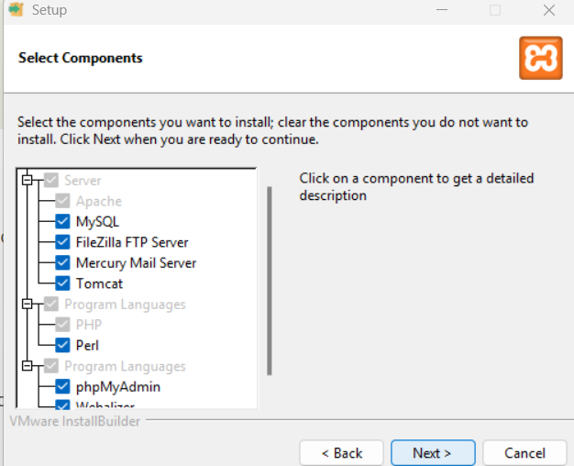

Click Next

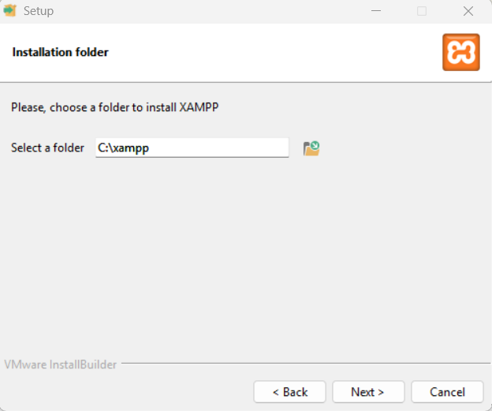

Click Next

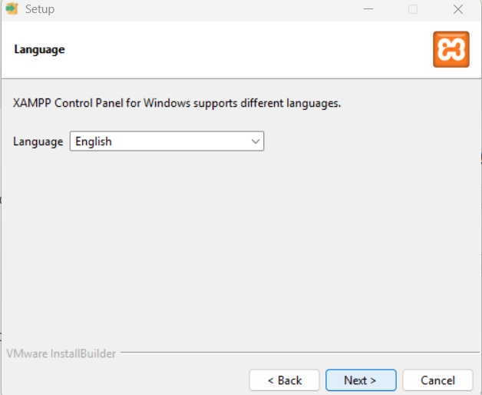

Click Next

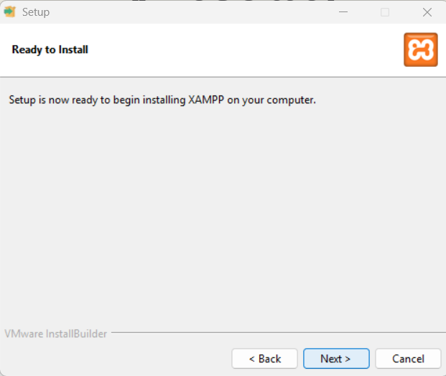

Wait for it to finish installing

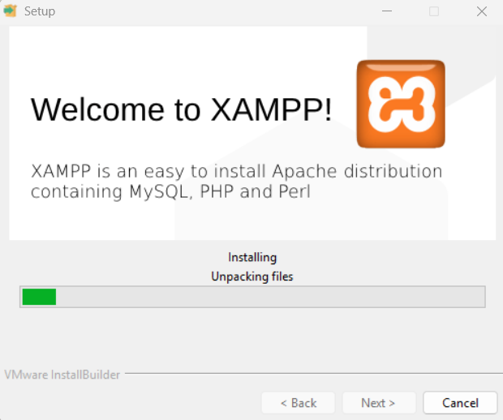

Click Allow

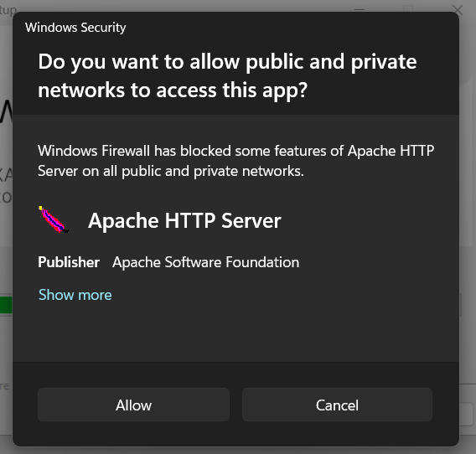

Click Finish

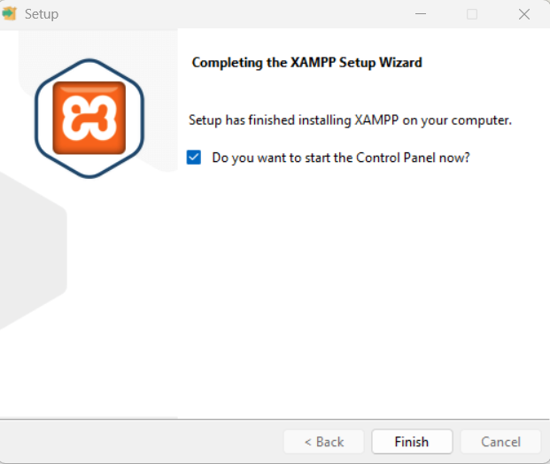

To test, press start on apache and mysql

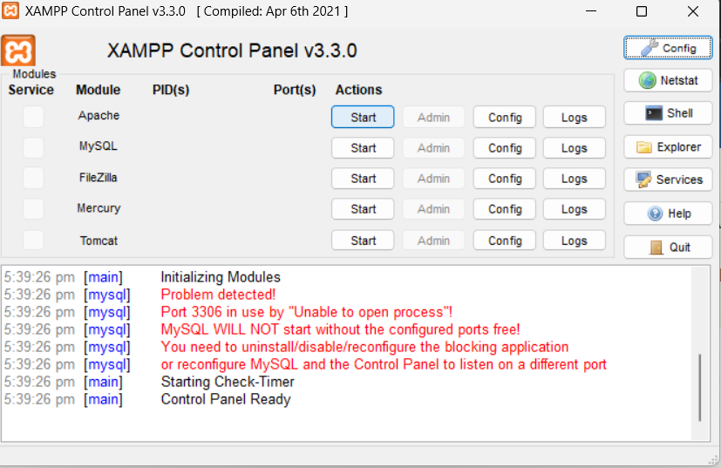

Go to your browser and type “localhost” in the search bar. If the following page appears, that means it is working properly.

